Name: Bradley Willcott

ID: M198449

Date: 15 October 2021

Assessment Task (AT 2.6)

Jupiter Mining Corporation

Contents

Figures 2

Debugging 3

Testing 5

References 27

Tables

Table 1: Testing results 5

# Figures

Figure 1 – Showing value of filename – from File/Open selection 3

Figure 2 – CSV file header line data – column headings 4

Figure 3 – Start-up RMI and Socket Servers 6

Figure 4 – Display About dialog - A 6

Figure 5 – Display About dialog - B 7

Figure 6 - Open a CSV file – File/Open 7

Figure 7 - Open a CSV file – File Open dialog 8

Figure 8 - Open a CSV file – Data in table 9

Figure 9 - Close and open a different CSV file – File/Close 9

Figure 10 - Close and open a different CSV file – File/Open 10

Figure 11 – Close and open a different CSV file – File Open dialog 10

Figure 12 – Close and open a different CSV file – Data in table 11

Figure 13 – Close and open a different CSV file – Displayed full screen 12

Figure 14 – Edit a record – Select a record 13

Figure 15 – Edit a record – Right click pop-up menu – Click Edit 14

Figure 16 – Edit a record – Edit Form dialog 15

Figure 17 - Edit a record – Modify the Title value 16

Figure 18 - Edit a record – Update the record 16

Figure 19 - Edit a record – Show result 17

Figure 20 - Save changed data to a new file – File/Save As 18

Figure 21 - Save changed data to a new file – File Save dialog 19

Figure 22 - Save changed data to a new file – New filename and status message 20

Figure 23 - Close and open saved file – File/Close 21

Figure 24 - Close and open saved file – File/Open 22

Figure 25 - Close and open saved file – File Open dialog 23

Figure 26 - Close and open saved file – Saved file is displayed 24

Figure 27 - Close and open saved file – Show modified record 25

Figure 28 – Exit application – File/Exit 26

# Debugging

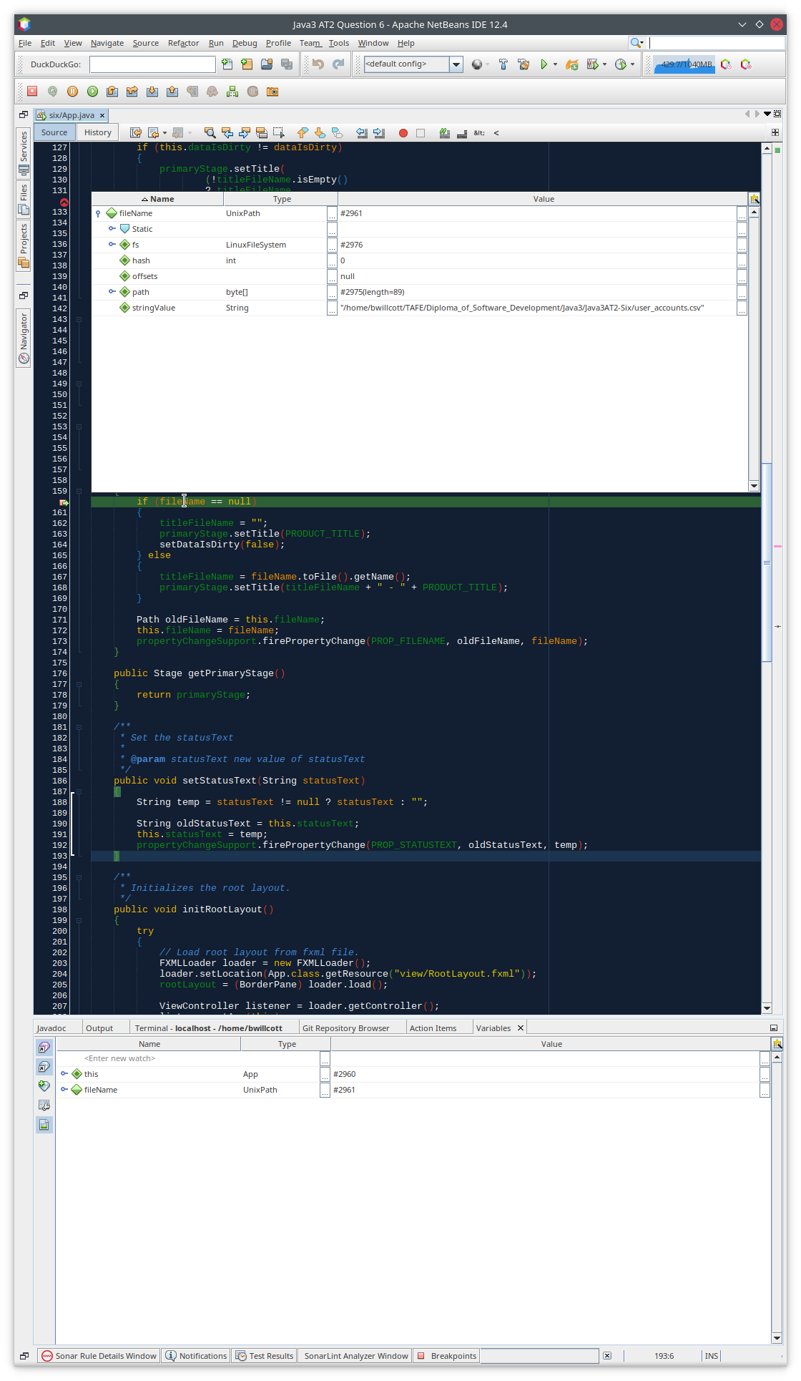

Figure 1 – Showing value of filename – from File/Open selection

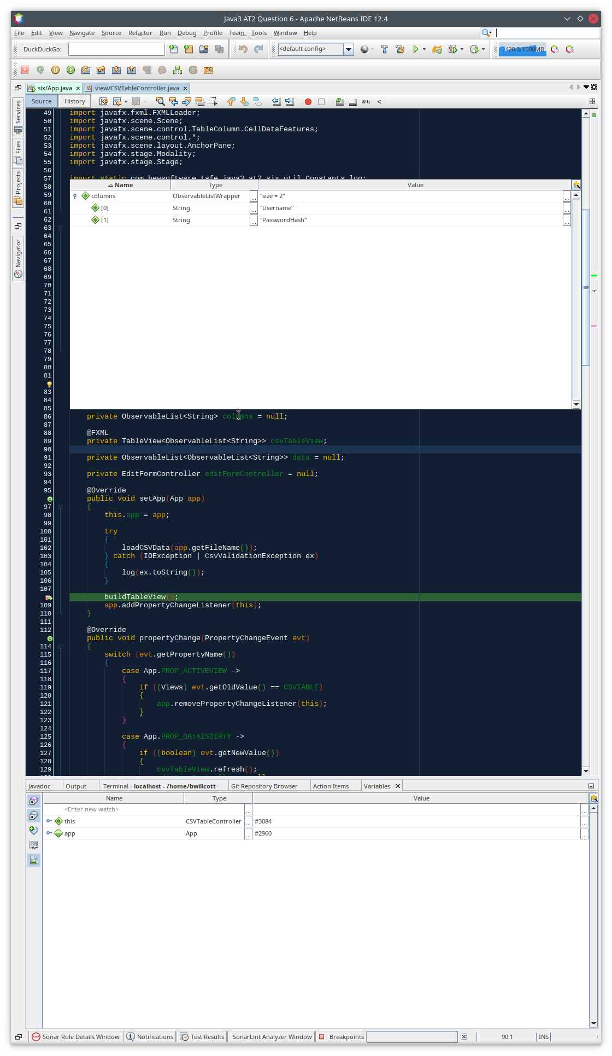

Figure 2 – CSV file header line data – column headings

# Testing

Table : Testing results

|  |  |  |  |  |
| --- | --- | --- | --- | --- |
| Case | Description | Expected | Actual | Evidence |
| #1 | Start-up GUI Application | Initial application screen | As expected | Figure 3 |
| #2 | Display About dialog | Dialog displayed | As Expected | Figure 4  Figure 5 |
| #3 | Open a CSV file: “user_accounts.csv” | Display File Open dialog, then display selected file in a table | As expected | Figure 6  Figure 7  Figure 8 |
| #4 | Close and open a different CSV file:  “Movies.csv” | Display File Open dialog, then display selected file in a table | As expected | Figure 9  Figure 10  Figure 11  Figure 12  Figure 13 |
| #5 | Edit a record | Display Edit Form dialog, then show edited value in table | As expected | Figure 14  Figure 15  Figure 16  Figure 17  Figure 18  Figure 19 |
| #6 | Save changed data to a new file: “Movies2.csv” | Display File Save dialog, then update status message | As expected | Figure 20  Figure 21  Figure 22 |
| #7 | Close and open saved file: “Movies2.csv” | Display File Open dialog, then display selected file in a table | As Expected | Figure 23  Figure 24  Figure 25  Figure 26  Figure 27 |
| #8 | Exit application | Program shutdown | As Expected | Figure 28 |

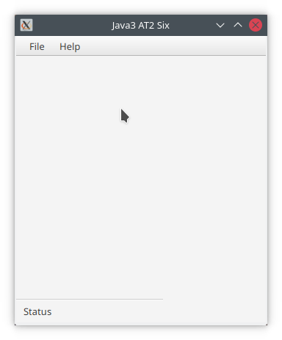

Figure 3 – Start-up RMI and Socket Servers

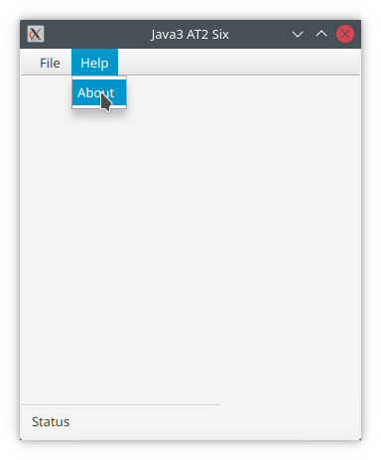

Figure 4 – Display About dialog - A

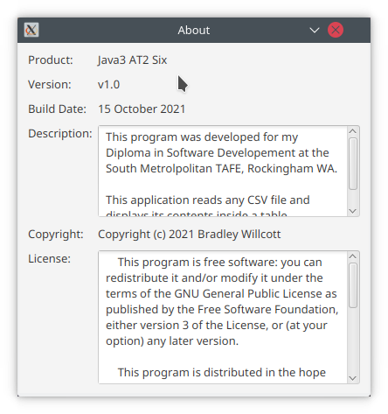

Figure – Display About dialog - B

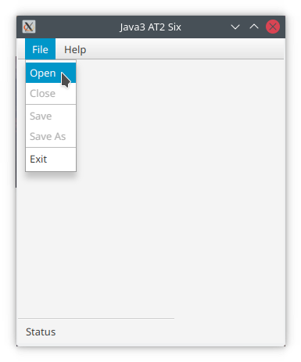

Figure - Open a CSV file – File/Open

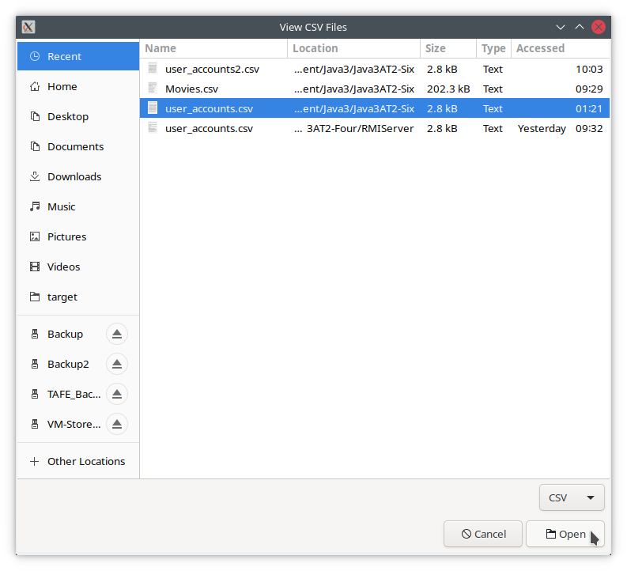

Figure - Open a CSV file – File Open dialog

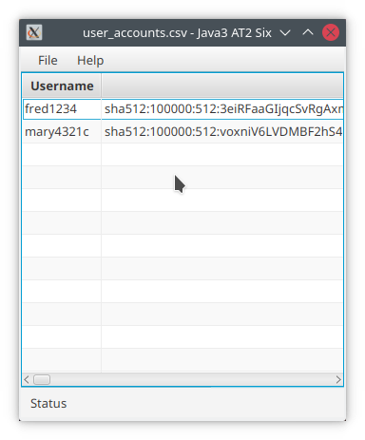

Figure - Open a CSV file – Data in table

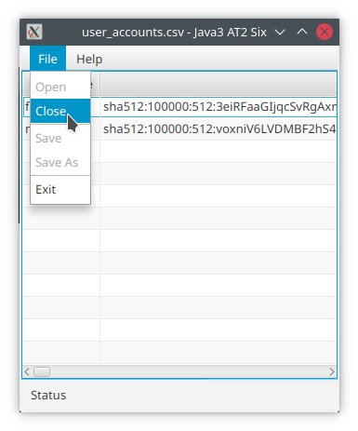

Figure - Close and open a different CSV file – File/Close

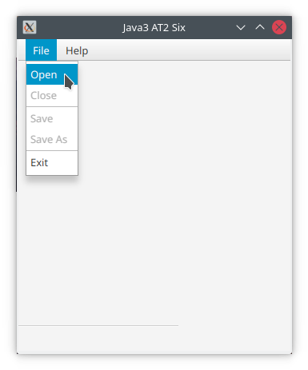

Figure - Close and open a different CSV file – File/Open

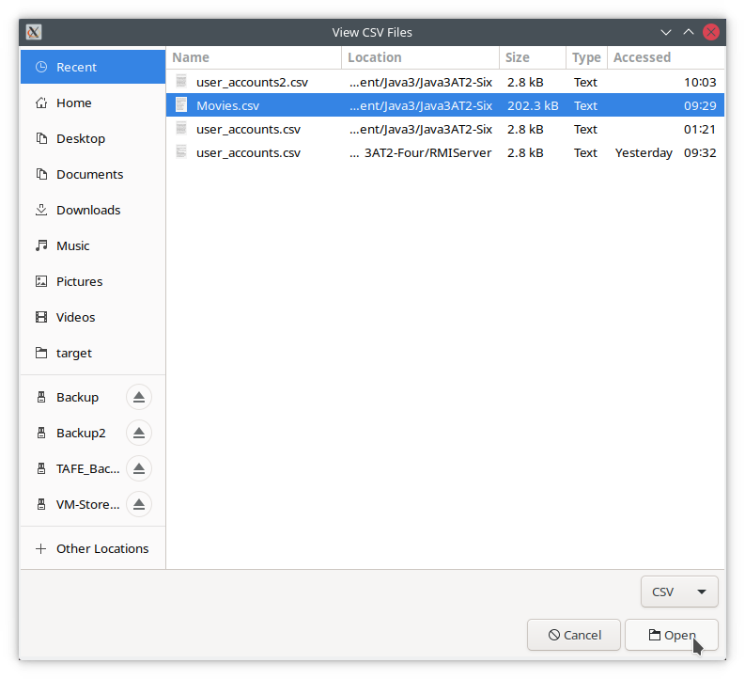

Figure – Close and open a different CSV file – File Open dialog

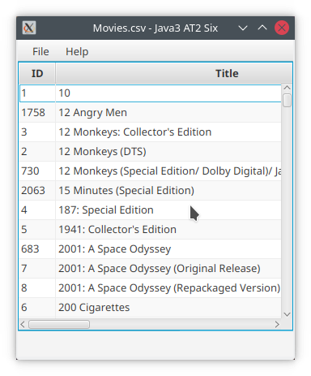

Figure – Close and open a different CSV file – Data in table

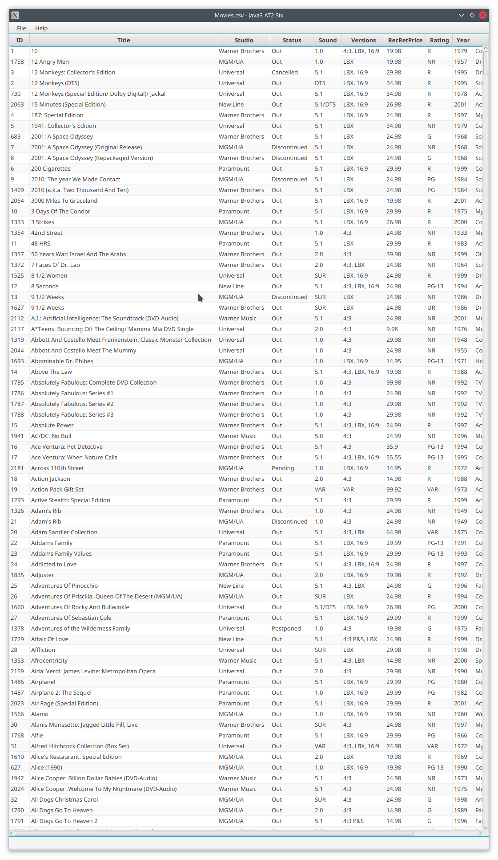

Figure 13 – Close and open a different CSV file – Displayed full screen

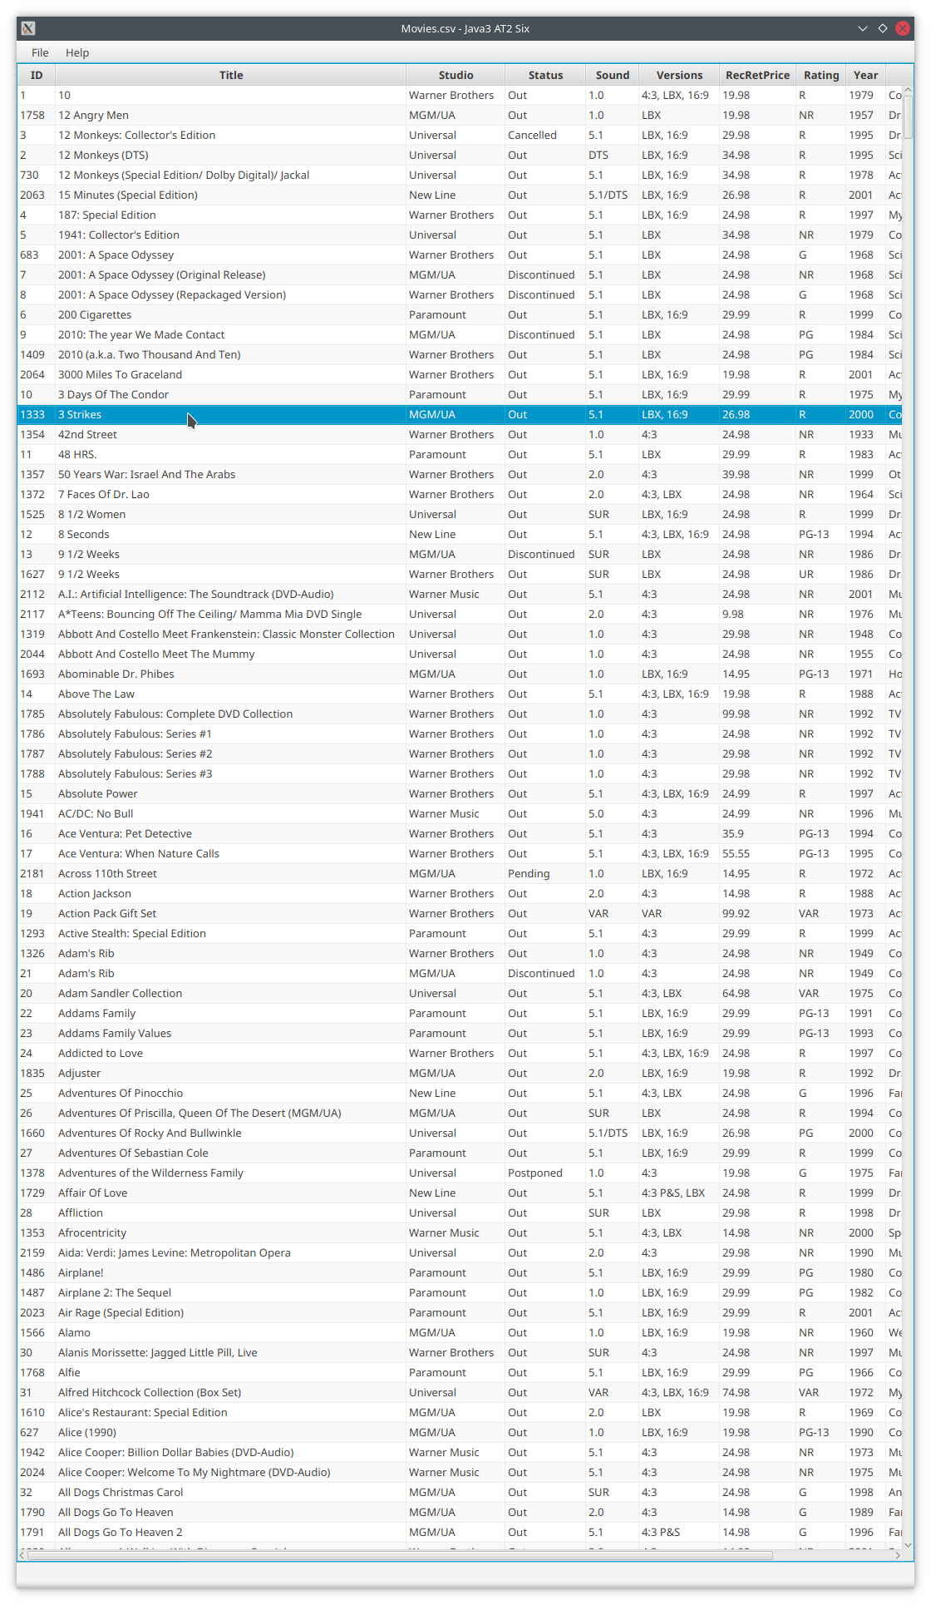

Figure 14 – Edit a record – Select a record

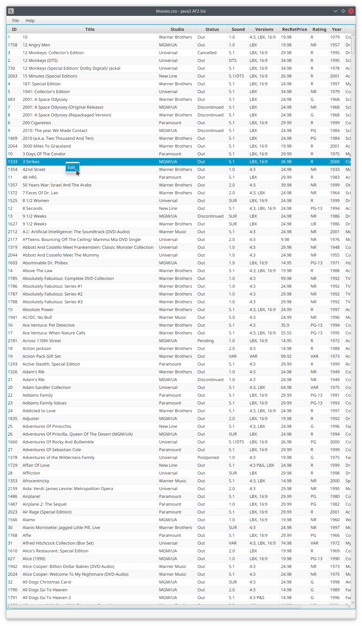

Figure 15 – Edit a record – Right click pop-up menu – Click Edit

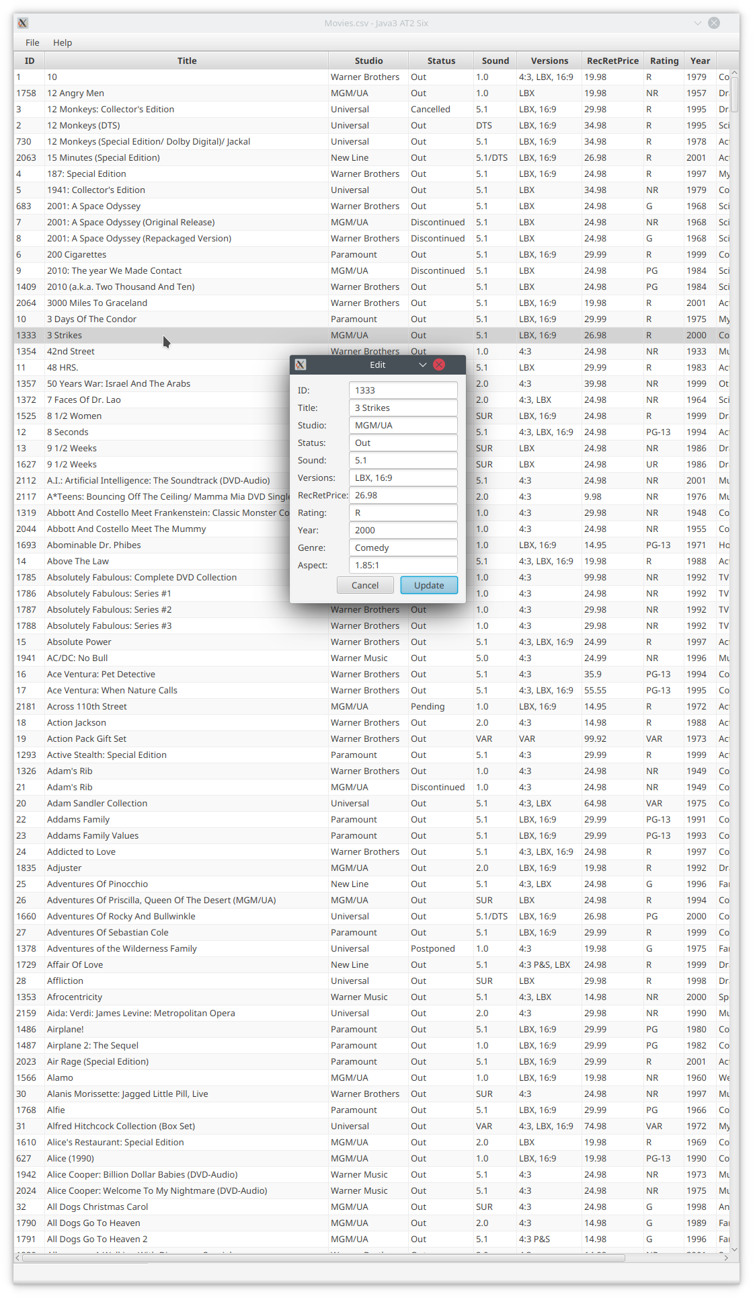

Figure 16 – Edit a record – Edit Form dialog

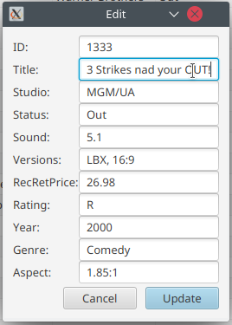

Figure 17 - Edit a record – Modify the Title value

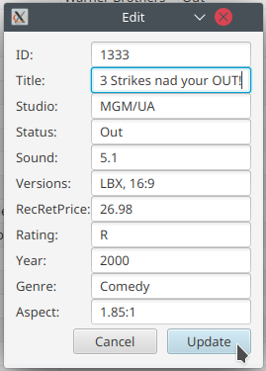

Figure 18 - Edit a record – Update the record

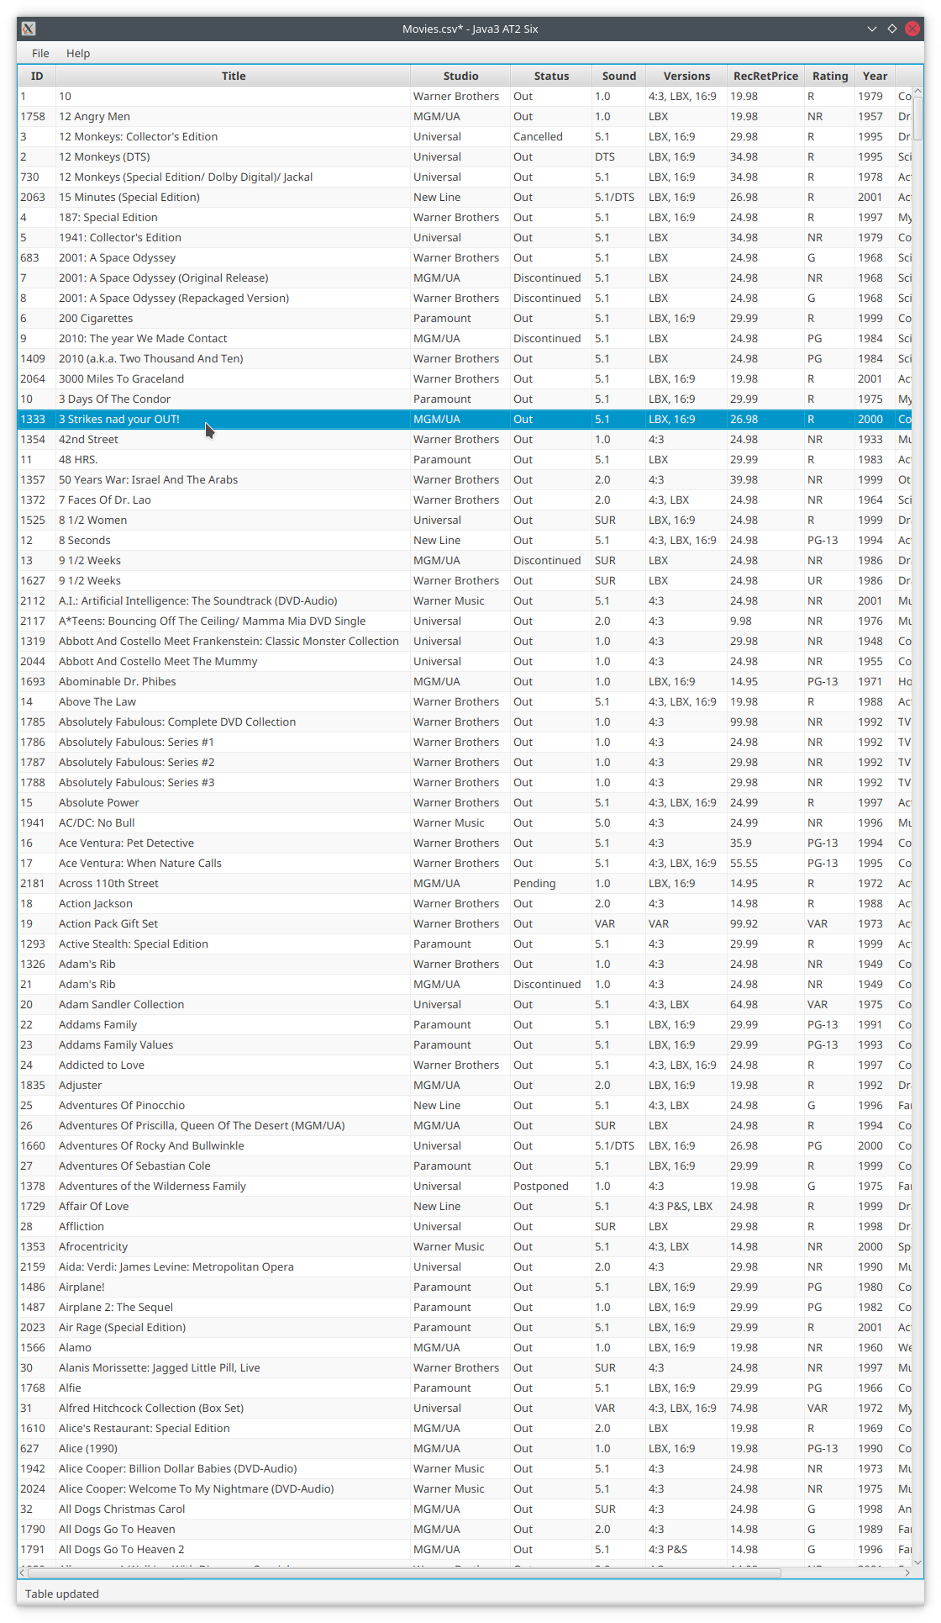

Figure 19 - Edit a record – Show result

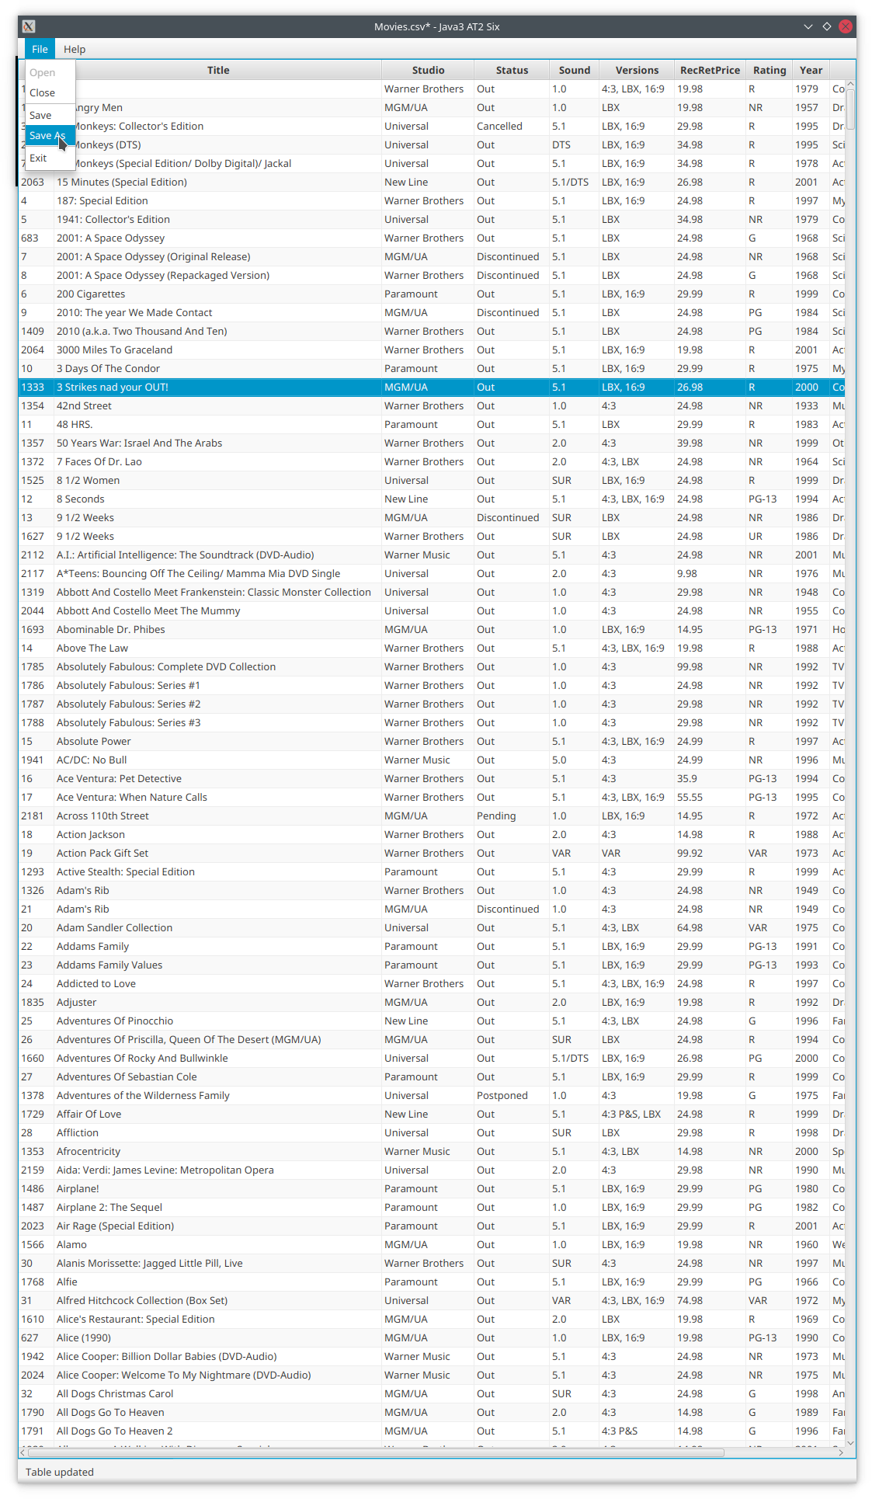

Figure 20 - Save changed data to a new file – File/Save As

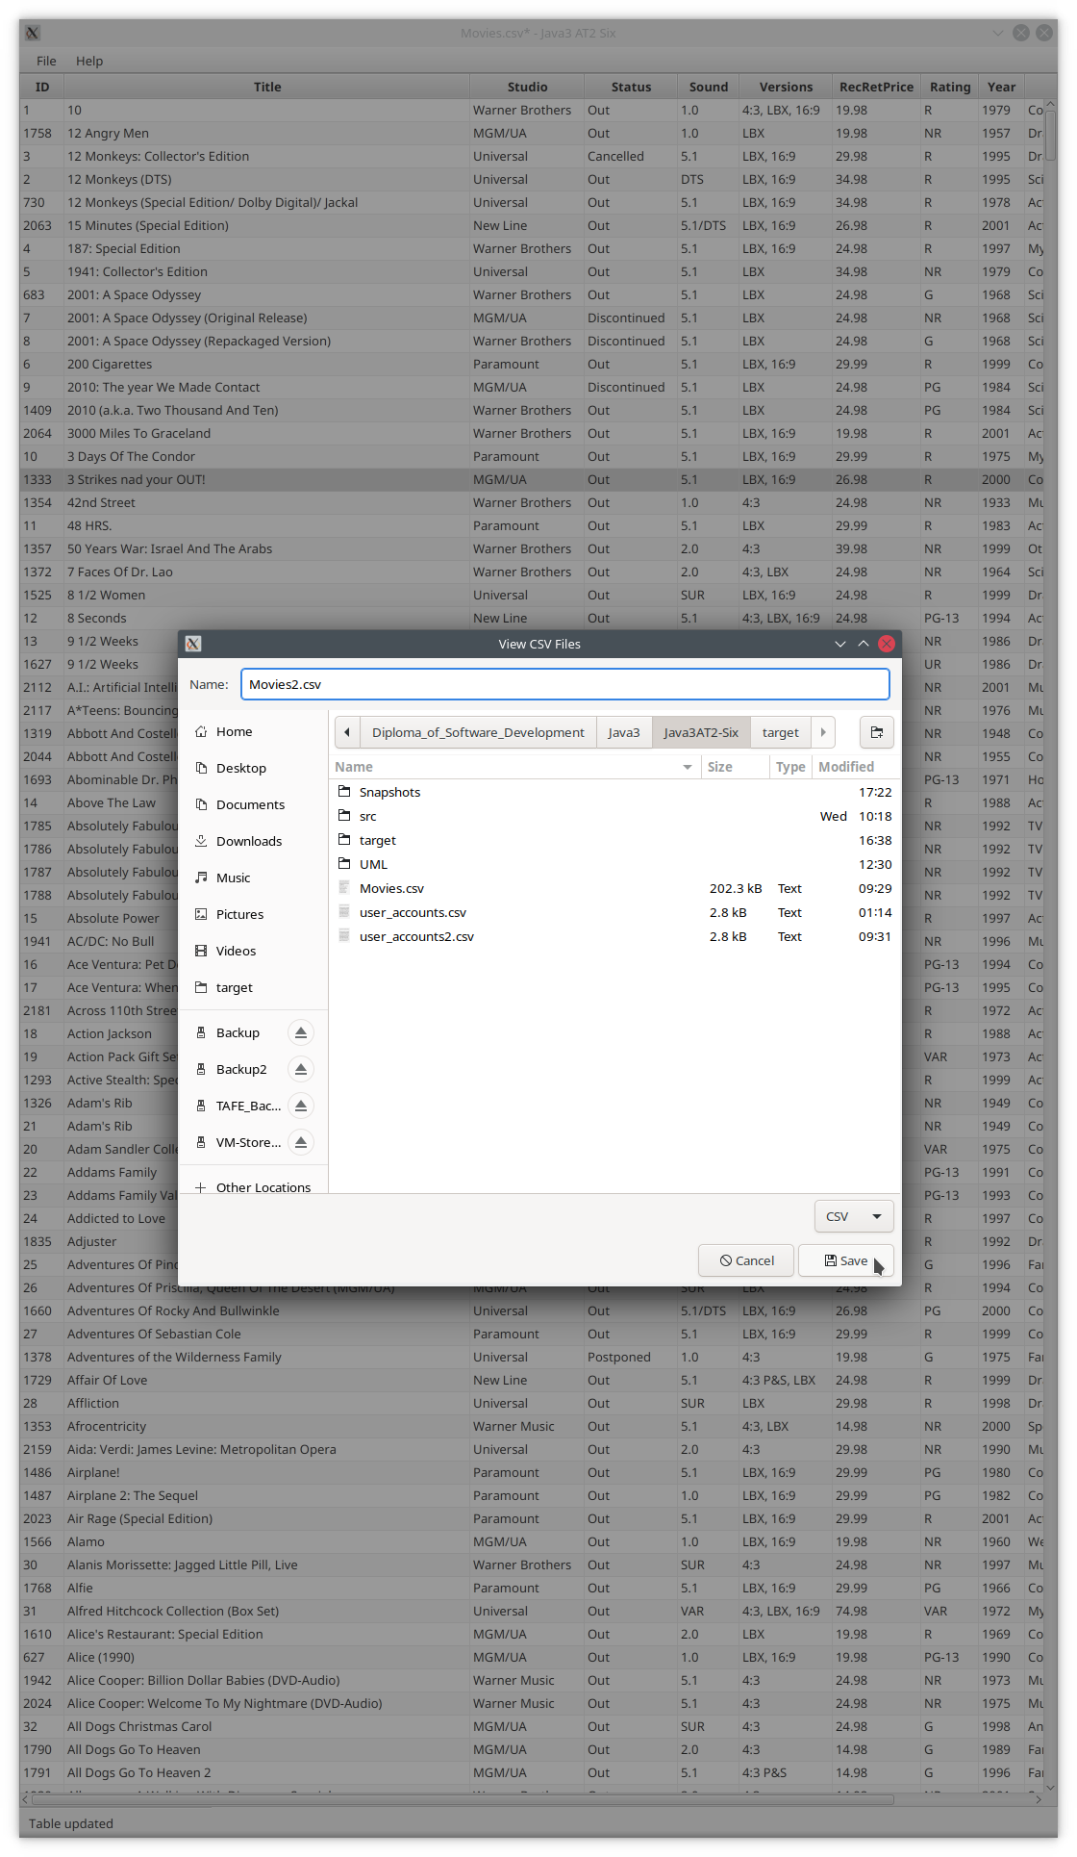

Figure 21 - Save changed data to a new file – File Save dialog

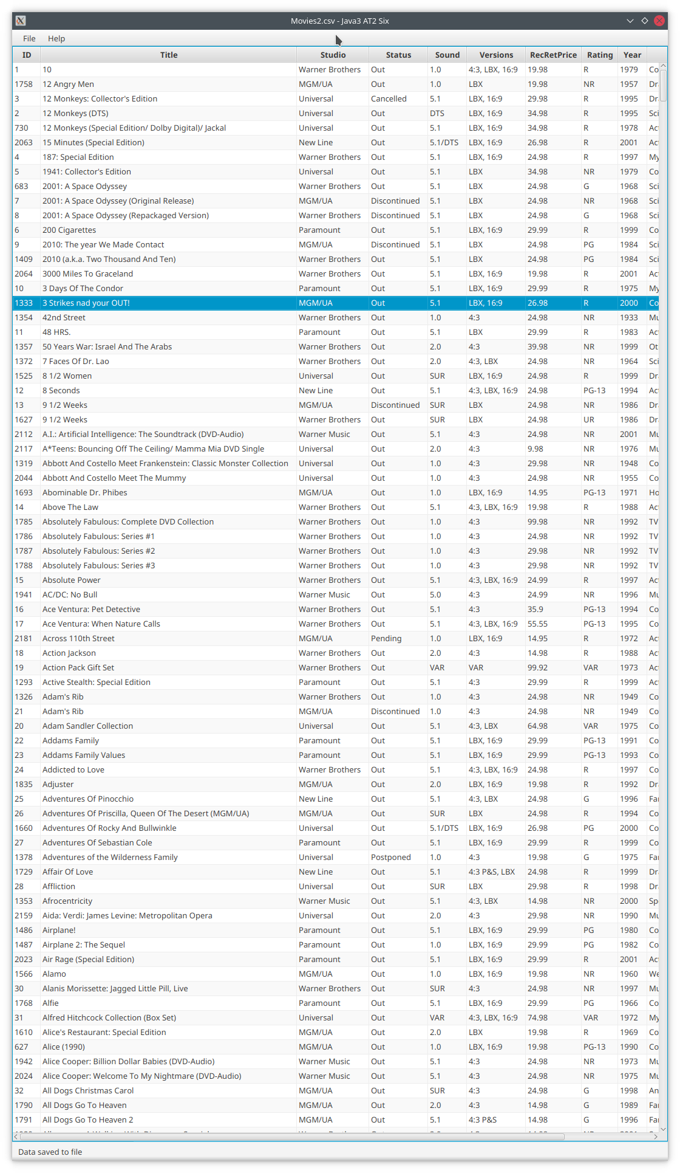

Figure 22 - Save changed data to a new file – New filename and status message

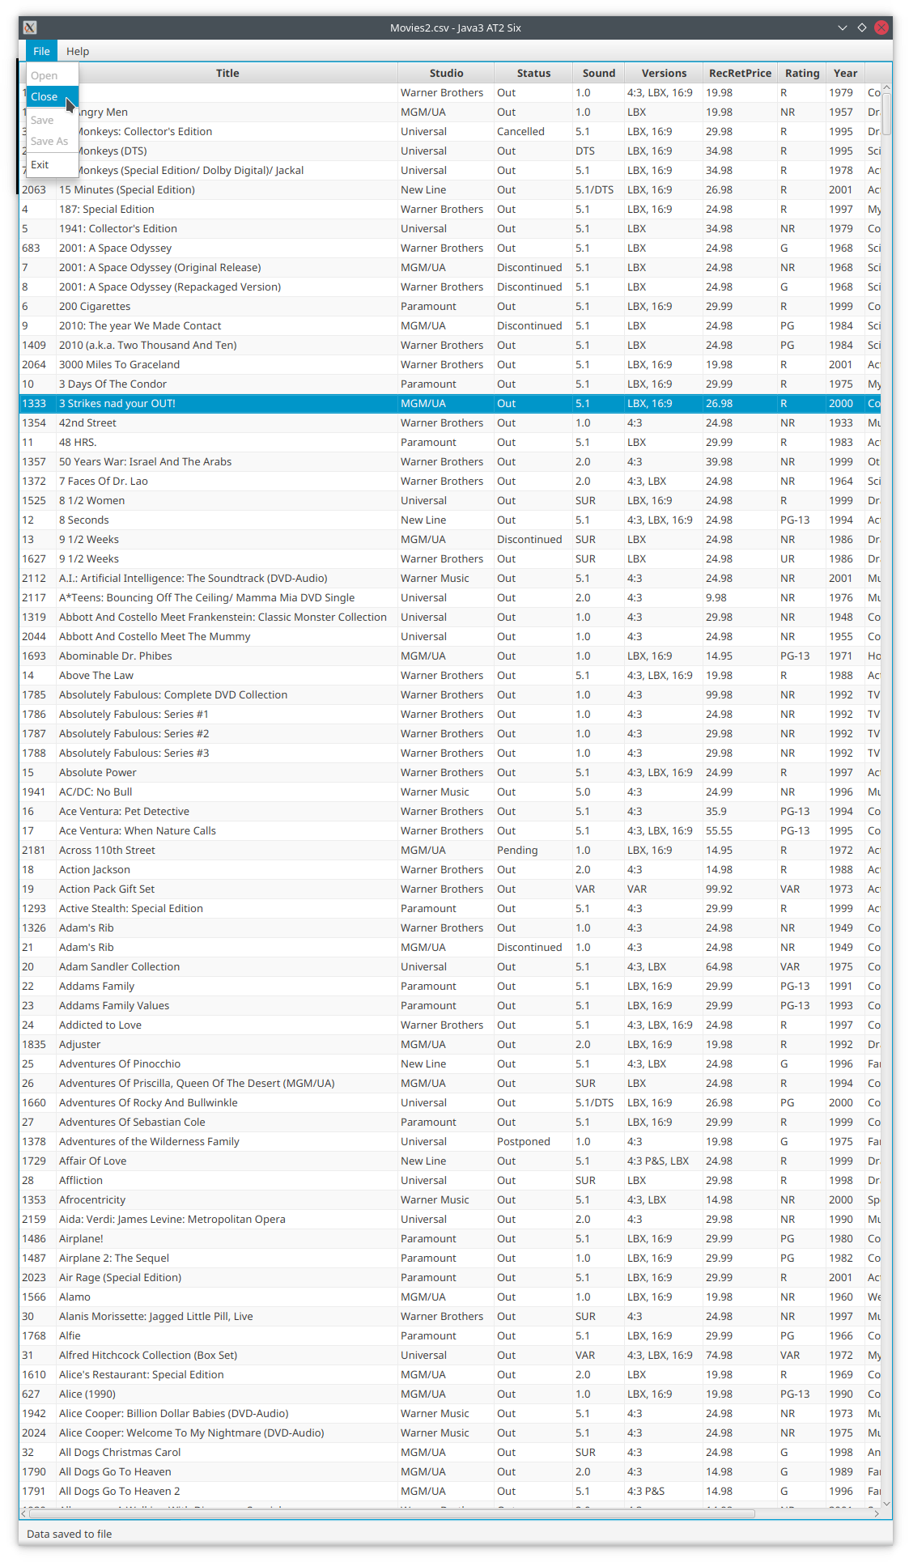

Figure 23 - Close and open saved file – File/Close

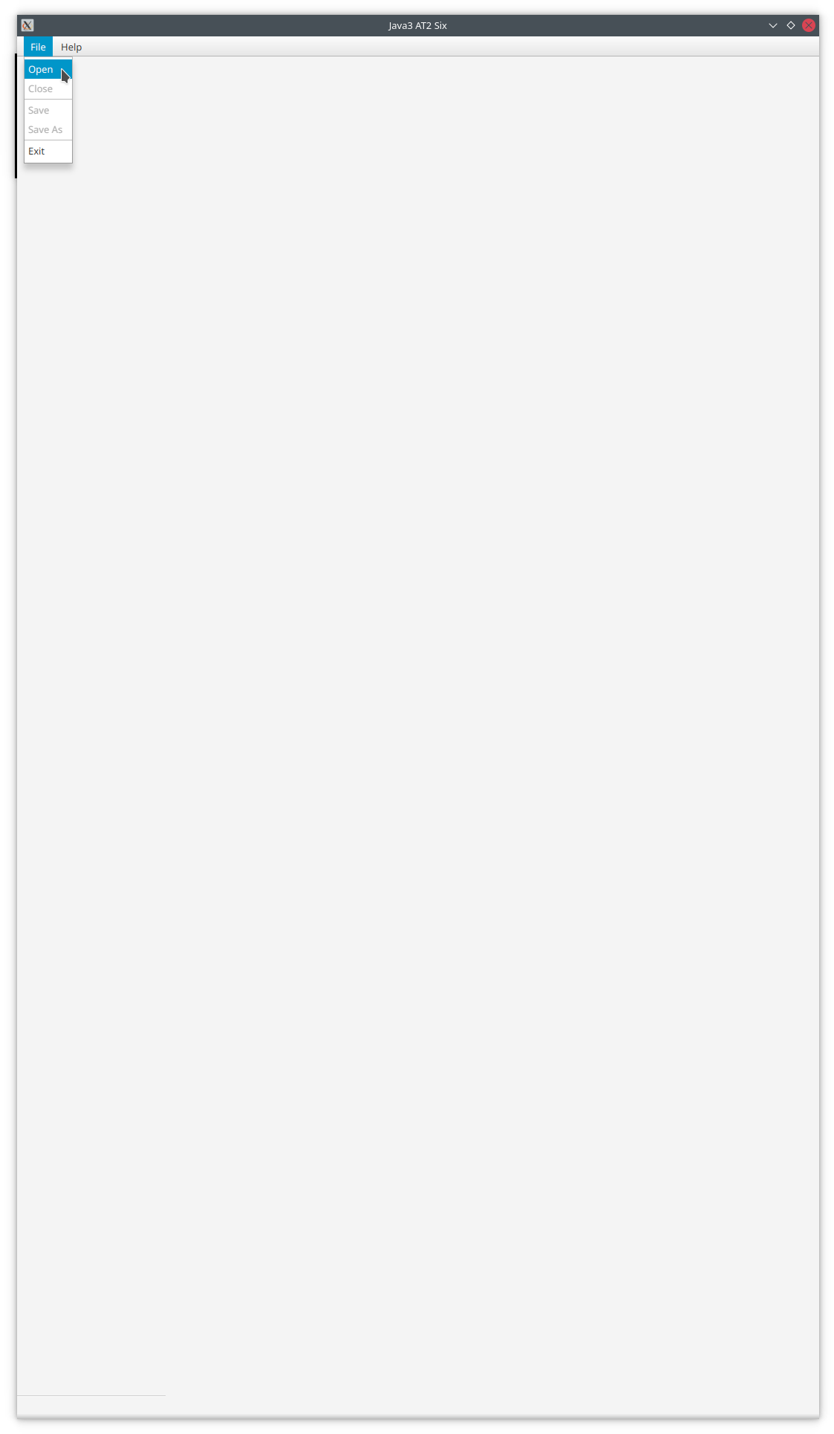

Figure 24 - Close and open saved file – File/Open

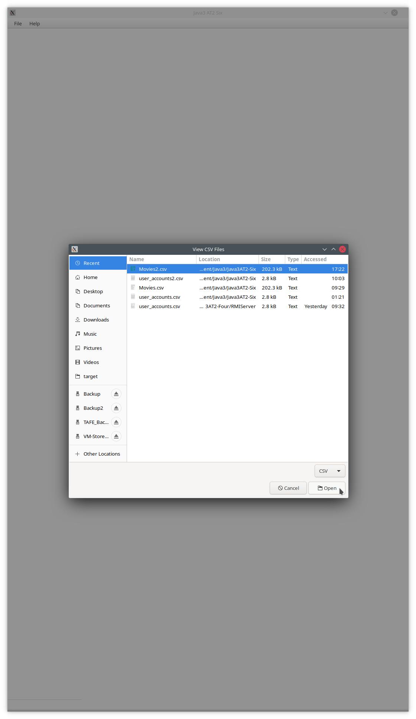

Figure 25 - Close and open saved file – File Open dialog

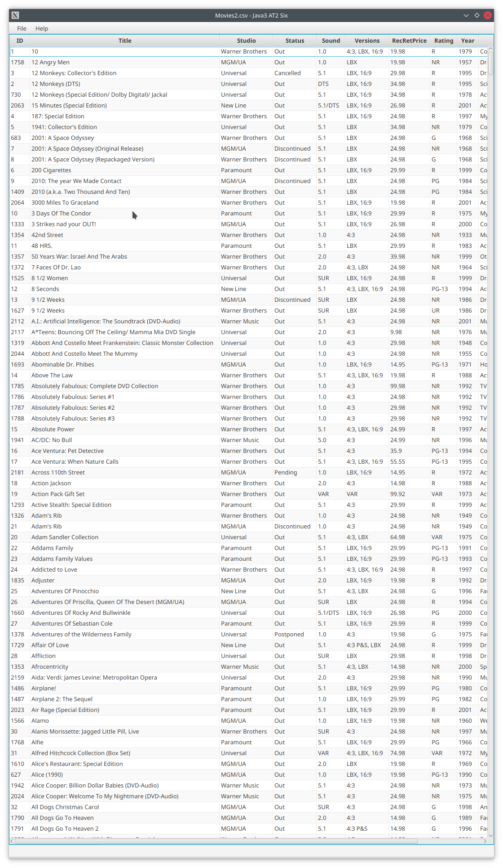

Figure 26 - Close and open saved file – Saved file is displayed

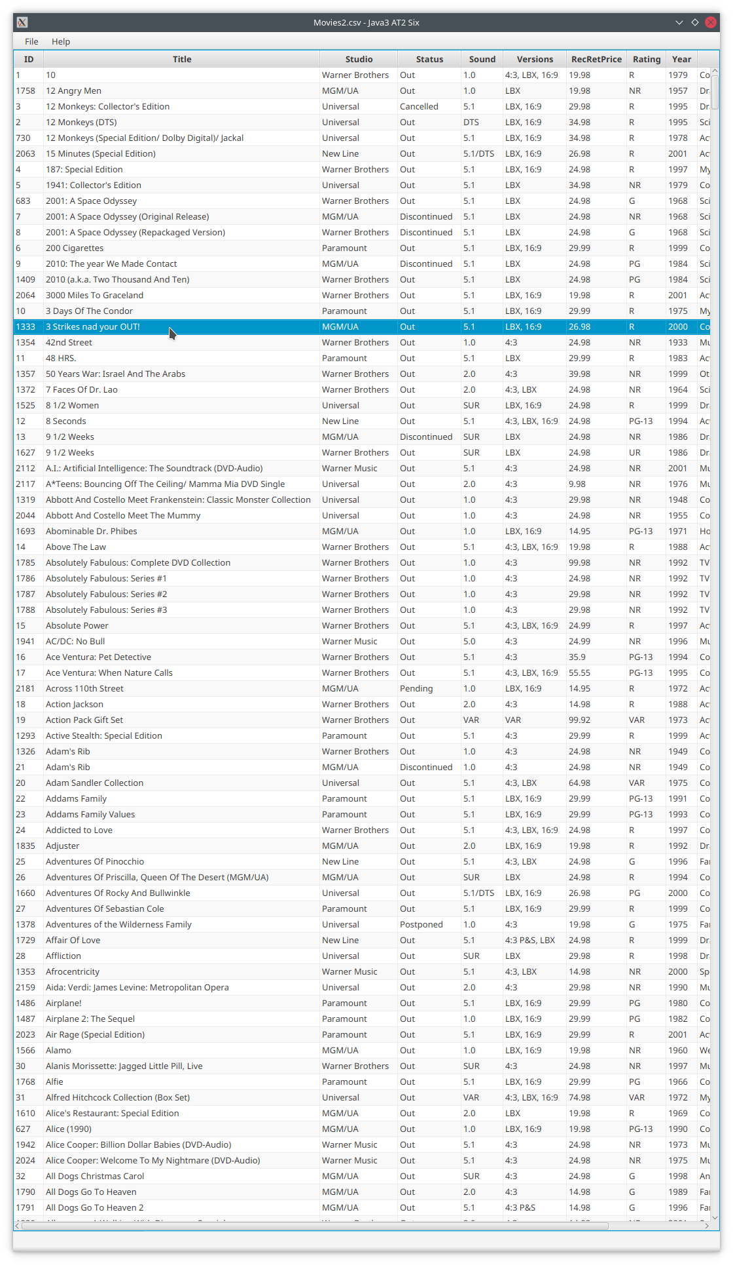

Figure 27 - Close and open saved file – Show modified record

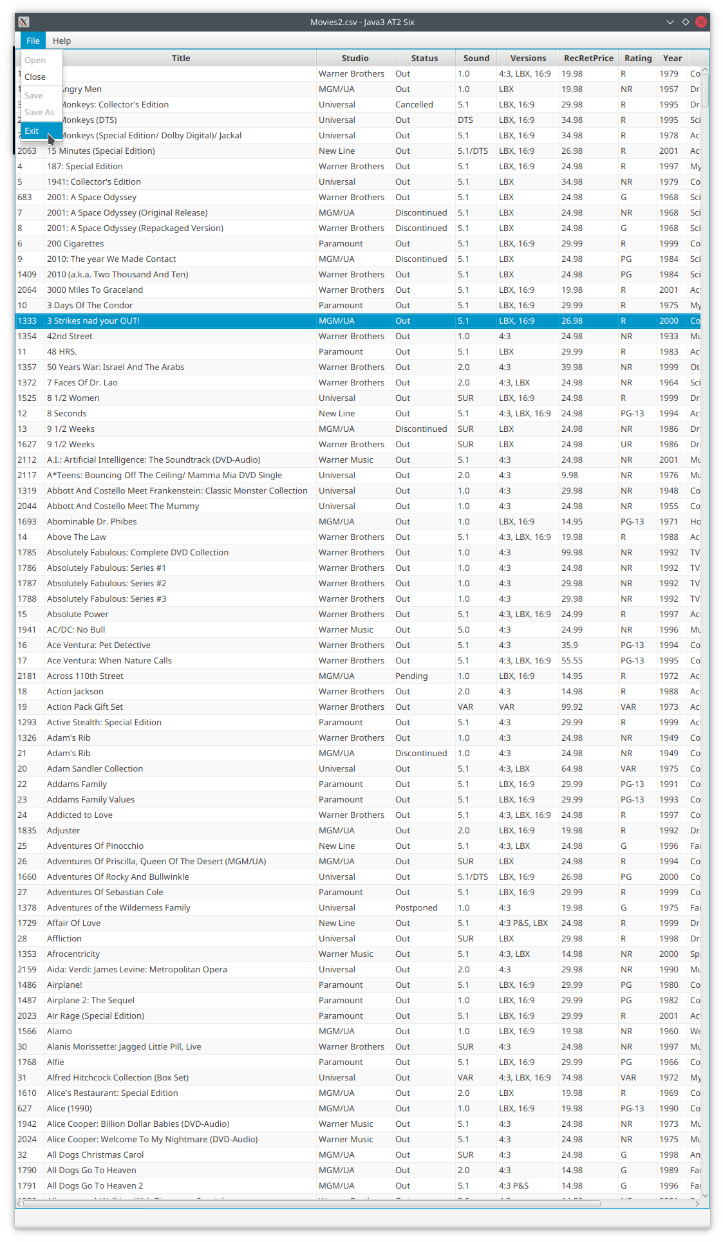

Figure 28 – Exit application – File/Exit

# References